Functional Specification

Puppeteer

## Group members:

Sandra Andersson **Dev**

Carl Appelkvist **Dev**

Ludvig Björk Förare **Dev**  
Anton Jonsson **Dev**

Kristoffer Lundgren **Dev**  
Filip Rehnman **Dev**

Philip Stenmark **Dev**

Benjamin Vesterlund **Dev**

Oscar Leiner Olsson **Artist**

Gustav Mårdestam **Artist**

Robert Ringholm **Artist**

## Document History

|  |  |  |  |
| --- | --- | --- | --- |
| **Revision** | **Date** | **Name** | **Comment** |
| A1 | 2019-04-11 | Sandra Andersson | First version for MS2 |

# Game Mechanics

## Core Game Play

Puppeteer is a party game over LAN where you play as 4v1 where 1 player is all-seeing. Playing as the all-seeing puppeteer you will have the power to manipulate the mansions rooms and place out traps and enemies for the other players to handle.

The other 4 players, the puppets, are to co-operate with each other in order to find the exit and survive. You need to defend yourself against the puppeteer’s minions with different types of weapons and power-ups with different abilities.

## Game Flow

As a regular player (puppet) you wake up in a bedroom alongside your other teammates. You will get a little time to explore the bedroom, pick up some weapons, ammo and other items and prepare yourself for the match. Once the time is over you will start to explore outside the bedroom and it appears at first sight that you are in an abandoned mansion. As you progress you can notice that there is something working against you, which is your main enemy, the puppeteer. Your main goal as a puppet is to escape from this mansion and the puppeteer’s traps and tricks.

You will find spawners that minions will spawn from that you need to destroy in order to survive and traps that you need to avoid, but you will also find other kinds of weapons, more ammo and also power boosts to charge your character specific power-up. If it happens that you run out of HP you will be knocked down for an amount of time. If that timer runs out you will die, but there is also the option to be revived by a teammate, using medkits that can be found, to come back to life. To help find a teammate you will have a compass that will show you the direction of where your other teammates are.

Playing as the puppeteer, you are the one that will control the entire mansion. The mission as the puppeteer is to kill all of the puppets and make sure that no one makes it out. You will be able to pick up and move, rotate and switch the different rooms. The puppeteer can only move the rooms under certain conditions, for example you can’t move rooms with puppets inside and you have to place the rooms in a formation so that there will be a path available from every puppet to the exit. The puppeteer will also have the ability to place different kind of traps and enemy spawners in different rooms. To have a bit of balance the puppeteer has a currency that will increase over time that he can use to purchase enemies and traps.

# Characters / Units (if applicable)

## Puppets

There will be 4 characters for the puppets, Froggo, Doggo, Gekko and Pekko. They all have an equal amount of HP. They can pick up and use different kinds of weapons for both ranged and melee attacks. All of the puppets will also have a compass for which they can use to see which direction their teammates are towards. The puppets have stamina bars for which they can use to sprint. The bar will automatically charge when not used. They also have their own unique power-up that they can recharge.

Froggo will get an **infinite stamina boost** for an amount of time. When activated Froggo will not need a stamina bar in order to sprint and will also get a stamina boost which means that Froggo will run faster and can even activate traps but will be able to avoid them.

Gekko will have the power to become **invisible** for a medium amount of time. He will become invisible for both the puppeteer and the minions, but not your teammates.

Pekko will get a **navigation boost** which means that the exit will appear on his compass for a short amount of time.

Doggo will get a **sniffer ability** where he can detect if there is a trap, or minions or power boosts, ammo or weapons for an amount of time. The doors for the rooms will light up in a specific color depending on what’s inside, for example red if there is something dangerous inside, blue for a boost, purple for both a trap and a weapon etc.

If a puppet dies, it will get a timer for being downed and the other teammates can revive the fallen before the timer runs out, or else the puppet will die.

## Puppeteer

The puppeteer is the player that has all-seeing powers. The puppeteer is not like the other entities since he doesn’t have HP and can therefore not be killed. The puppeteer can see all of the rooms, the puppets, his spawners and minions and his traps. The only things the puppeteer can’t see are the randomly placed weapons, ammunition, power boosts and ?????

## Minions

There are two types of minions, the small ones that spawns from spawners and bigger ones that don’t need spawners, but can’t roam. Both of them has HP and can be killed and performs melee attacks towards the puppet. The smaller minions needs a spawner that the puppeteer will place out. Once a minion dies, a new one will spawn out of the spawner until it’s destroyed. The smaller enemies also have a faster movement speed than the puppets, while the big minions are slower than the puppets. For more information about the behavior, read “Artificial Intelligence”.

# Game Play Elements

## Puppet Items

### General

Only the puppets can wield the weapons for both ranged and melee attacks. A puppet can only have one weapon at a time so they don’t have any kind of inventory. They can find new weapons throughout the map that they can switch to, but they have to leave the old one behind. That means that puppets that have a strong weapon and find a stronger one, can leave their old one behind for another puppet to pick it up.

All items such as weapons, ammunition, medkits and power boosts will be randomly placed around the map.

### Shotgun

The shotgun is best for close combat. It will have a short range so the further away your target is, the less damage it will make. It has a high spread so it will cover a large area. The whole area of the shotgun has high damage, but the individual particles has low damage. So, the closer you are to the target, the more damage it will make. It has a medium fire rate since it’s not automatic. The shotgun has low accuracy, because it has a high spread.

### Rifle

The rifle has the highest damage and the furthest range, but it has a very low fire rate. It has a high accuracy. It is best used for single targets on long range

### Pistol

The pistol is the starting weapon. It has a low fire rate, low damage and medium range. It has a high accuracy, but not as high as the rifle.

### Gatling Gun

The gatling gun has a low damage for each bullet, but a high fire rate and lots of spread. It has a medium accuracy. It is best used for multiple targets on medium range.

### Ammunition

In order to use your weapons you need ammunition. The ammunition works for all weapons so there are no weapon specific ammo.

### Power Boosts

Power boosts can be found throughout the map and are needed for the puppets to use their power-ups.

### Med Kit

The puppets can find medkits placed all around the map. A puppet can only have 1 med kit at a time and they can only be used for reviving downed allies.

### Compass

Each puppet starts out with a compass. This compass is illustrated at the top of the screen and shows the player in which direction its teammates are.

## Puppeteer Items

### Spikes

The spikes can be placed both in the roof and on the ground. They will be hidden until the puppet triggers it. It will then shoot up or down and deal damage to the puppet. If you watch closely you may see the spikes depending on where it’s placed, for example it’s completely hidden if it’s underneath a carpet. The spikes will have an activation time, so it will take a very small amount of time until it’s activated so that Froggo can escape it when she has his boost.

### Fake Item

The fake items are traps, with skins as regular items such as stamina boosts, weapons and ammo. When a puppet will try to pick up a fake item it will explode and make damage to the puppet.

### Bear Trap

If a puppet walks onto a bear trap the puppet will get stunned and won’t be able to move. You will take a basic amount of trap damage and you can choose to wait for a teammates to come and release you, or take it on yourself but take extra damage for it.

### Chandelier

If a puppet walks underneath a chandelier it will be triggered and dropped upon the puppet and make damage.

### Minions

For more information about the minions and their behavior, go to “Artificial Intelligence” or “Minions”.

### Spawners

The spawner is the smaller minions spawning point. Once a spawning point is placed, the minions will start spawning until the spawners spawning cap is reached. If a spawner is attacked it will send a message to all of its minions in order for them to run back and defend it. If the spawner is destroyed no new enemies will start to spawn.

### Rooms

All of the items that the puppeteer can place throughout the map can only be placed on certain positions. For example you can’t place a spawner right in front of the door because it will have pre-defined positions that you can choose to snap it to.

### Doors

In order to move a room you need to place the room so that the door/doors are connected to other doors. If there is

# Game Physics and Statistics

We’re going to need some basic physics like jumping for the puppets, basic collisions between entities and walls etc. For everything physics related we’re going to use Unity’s own physics engine.

# Artificial Intelligence

## Small Minions

After the spawner has been placed, the minions will start roaming around, but not too far from the spawner. They can move between rooms, as long as it’s in the spawner’s area. If a minion finds one of the puppets on its exploration, it will start to chase the puppet. The minion will keep chasing the puppet until it is dead, it has run too far from the spawner or the spawner is attacked. If the spawner is attacked all of the minions connected to the spawner will run back and start to defend it.

## Big Minions

The big minions cannot roam around, but will stay inside the room where it is placed and walk around inside it. If one of the puppets walks into the room it will react and start chasing the puppet endlessly. The difference between the small and the big minion is that the small ones will chase the puppet, until it’s too far from the spawner, but it’s faster than the puppet so it will get up to speed to it some time. Meanwhile the big minions can’t really keep up with the minion, but will instead never stop chasing the player until either one has died.

# Multiplayer

The multiplayer type is team vs solo since there will be a group of puppets working against the all-seeing puppeteer. It will require at least 2 players (1 puppeteer and 1 puppet) and can support at the most 5 players (1 puppeteer and 4 puppets). The networking method is that there will be 1 host.

# User Interface

* Menus
  + Start Menu
  + Lobby
  + End Screen
  + Guide
  + Credits
* Puppeteer
  + Cooldown
  + Room selection
* Puppets
  + Health
  + Stamina
  + Ammunition
  + MedKits
  + Power-up status
  + Compass

## Flowchart

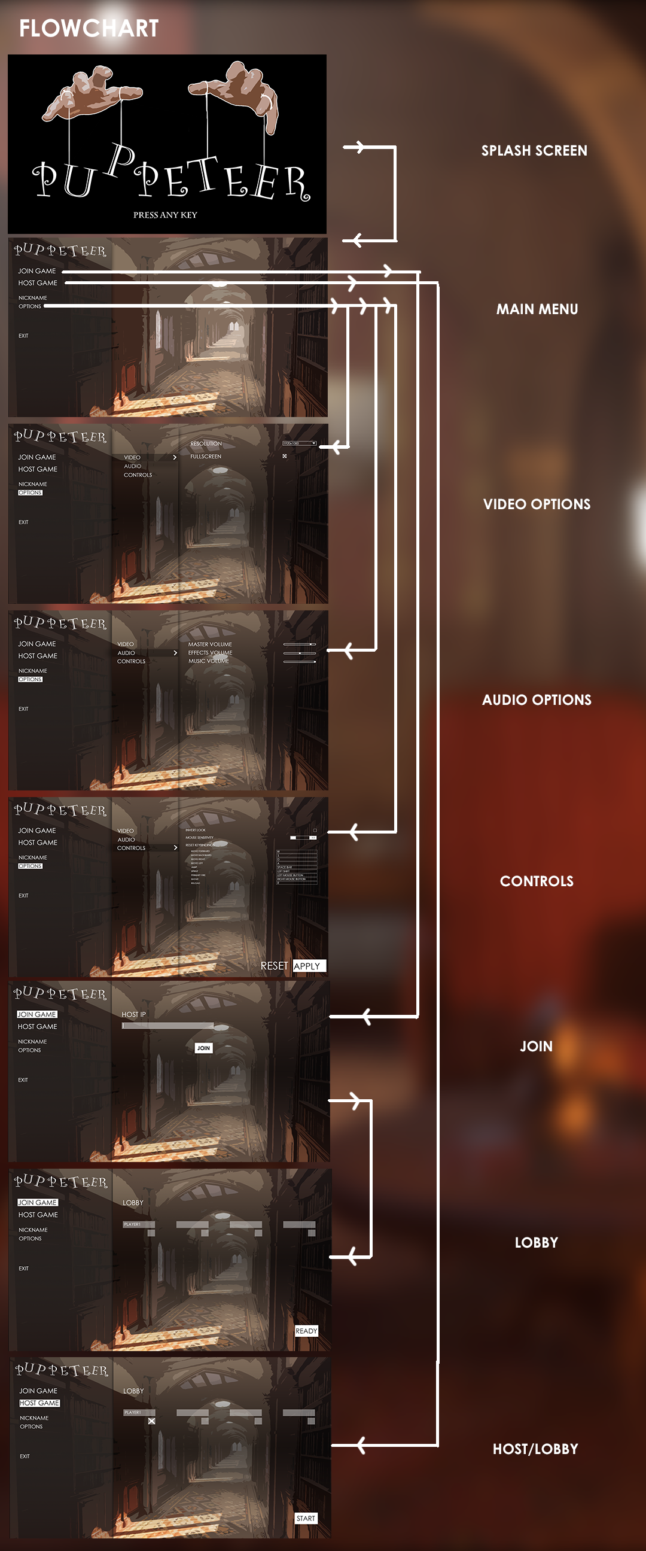

## Mockups

### Puppet Gameplay

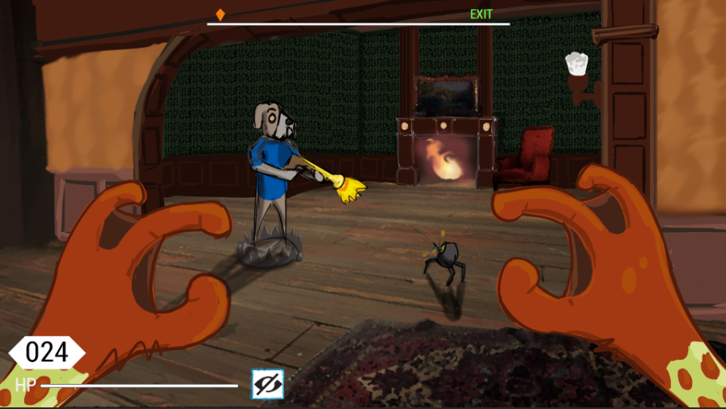

### Puppeteer Gameplay

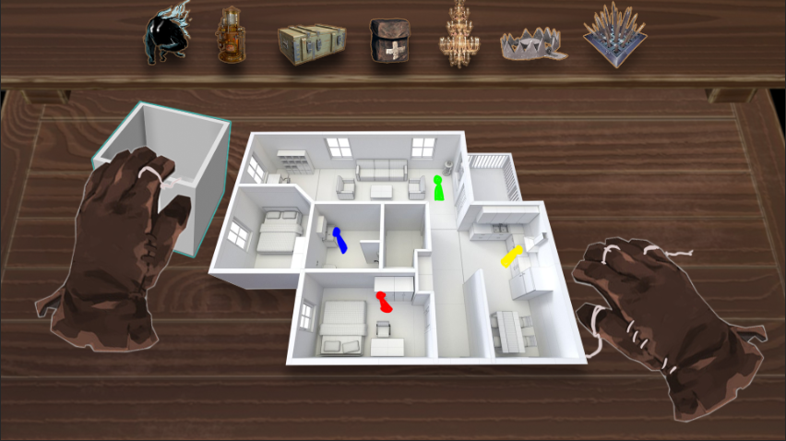

# Art and Video

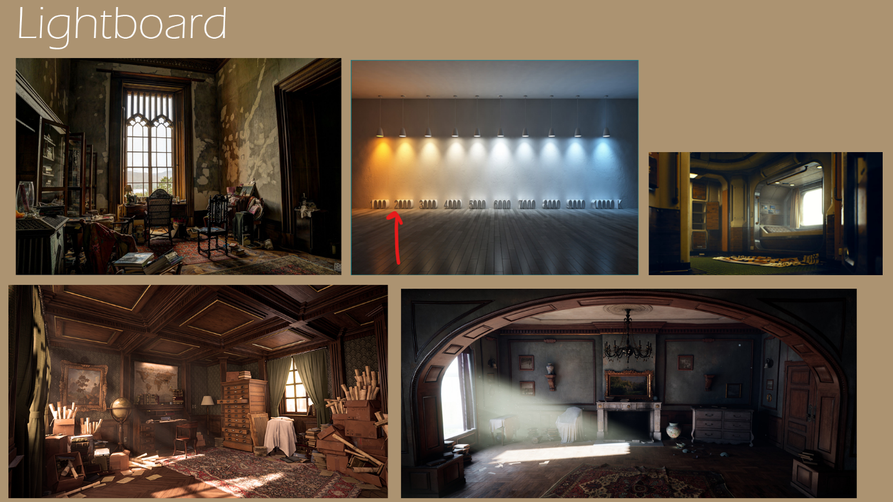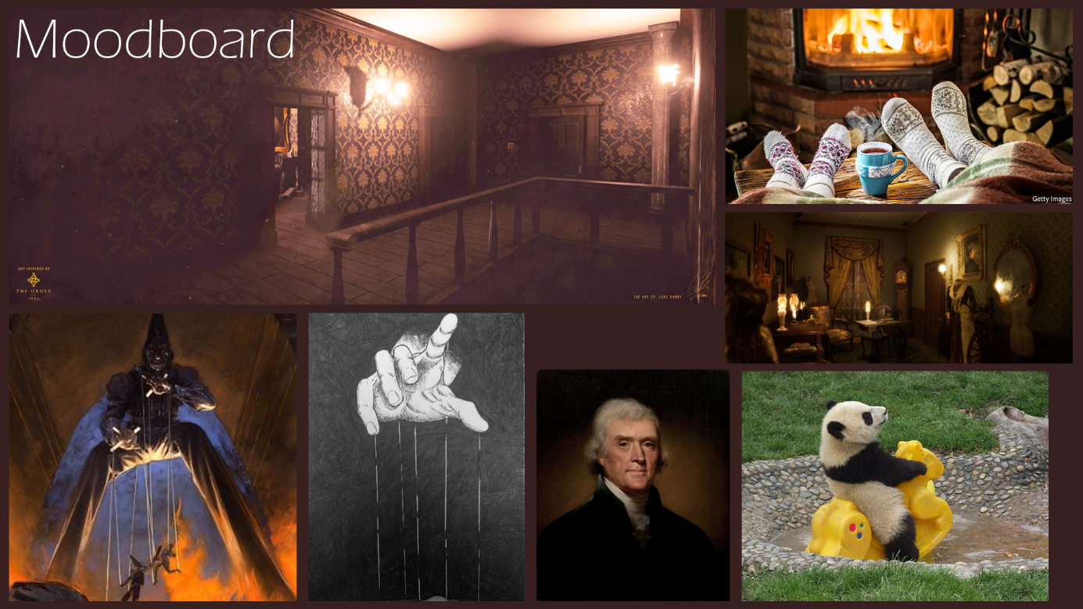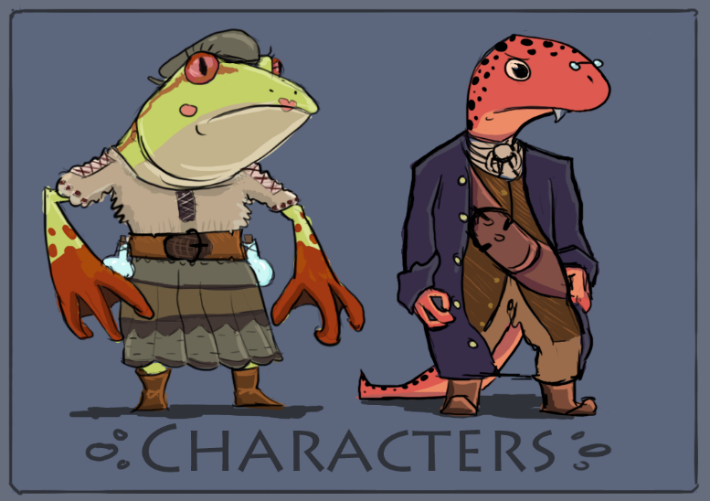

Figure 1 Character Art for Froggo and Gekko

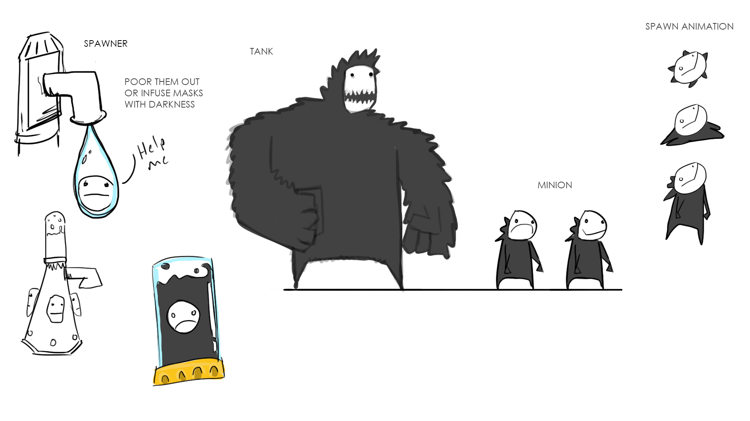

Figure 2 Character Art for the Minions

# 2D Art & Animation

## GUI

* Marker
* Splashscreen
  + “Puppeteer”-Logo
* Main Menu
  + “Puppeteer”-logo
  + Tab-arrow
  + Checkbox-Cross
  + Sliders
* Lobby screen
  + Info/lore boxes

## Marketing and Packaging Art

* Poster
* Box Art
* Manual
* Trailer

## Terrain

* Textures for all assets
* Decals
  + Bullet holes
  + Worn wallpaper
  + Scribbles

## Game Play Elements

* Ammo Count
* Health Bar
* UI - Compass
* Power-up available/ duration Icon/Bar
* Stamina Bar
* Interaction icon

## Special Effects

* Panning Textures
  + Muzzle Flares
  + Explosions
  + Gas
  + Glare (Traps)

# 3D Art & Animation

## Modular Room Assets

* Straight Wall (4 different textures)
* Corner Wall (4 different textures)
* Window Wall (4 different textures)
  + Curtains + rods (3 different textures)
* Fireplace Wall (2 different models and textures)
* Roof (2 models, 2 different textures each)
* Floor (4 different textures)
* Support Pillar (2 different models and textures)
* Floor, roof and corner baseboard (4 different textures)
* Room divider (2 different models and textures)
* Doors + doorframe (2 different models 2 different textures each)
* Radiators
  + Pipes (Made modular)

## Furniture

* Bookshelf
  + Books (2 different models, 5 different textures per model)
* Painting
  + Frame
  + Picture (11 different textures)
* Chair
* Table (Made modular, so that long-tables can be made)
* Desk
* Rugs (3 different textures)
* Armchair
* Floor Clock
* Mirror (2 different textures, 1 broken 1 dirty)
* Couch
* Ladder
* Vase (3 different models and textures)
* Standing Earth globe
* Chandelier
* Lamp
  + Floor
  + Desk
* Candles (2 different models and textures basically 2 different heights)
* Coal burner
* Clothes hanger
* Bed

## Items

* Heal Item (Medkits/Syringe)
* Power-up
* Weapons
  + Shotgun
  + Rifle
  + Pistol
  + Gatling gun
* Ammo box
* Enemy Spawner

## Characters

* Puppets (Will share skeleton, has 1st person versions with only hands and arms present)
  + Doggo
  + Froggo
  + Gekko
  + Pekko
* Puppeteer
* Enemies
  + Small
  + Large

# Sound and Music

## Overall Goals

The themes and moods for the music and sound is eerie, fun, goofy and yet serious with a style of 1800th Victorian era. .wav will be used for file format.

* General environment info:
  + Floor type: Wood
    - Doors are made of wood and heavy

## Sound FX

### GUI

* Click button
* Hover over
* Transition

### Special Effects

* **Weapons**
  + Shotgun: Shoot, hit, reload
  + Rifle, shoot, hit, reload
  + Pistol: Shoot, hit, reload
  + Gatling gun: Spin up, spin down, shoot, reload, hit
* **Traps**
  + Spikes: Extend, retract
    - [Example: Extend and retract (ignore deploy sound)](https://youtu.be/28pKZgqzBGw?t=19))
  + Chandelier: Drop, Hit ground
  + Bear trap: Closed, opened
    - [Example closing](https://youtu.be/326EDMDpbQw?t=562)
  + Fake item: Explode
    - [Explosion (but without high pitch ping)](https://youtu.be/c9rl-U9uhk8?t=7)
  + Enemy spawner: Idle, spawn enemy, destroyed

### Characters

* **Enemies**
  + Small minion:
    - Idle, Walk, run, attack, hit, die
  + Tank:
    - Idle, Walk, attack, hit, die
* **Puppets**
  + General sounds:
    - Walk
    - Run
    - Jump
    - Land (after jump)
    - Use medkit/revive other player
  + **Froggo**
    - Take damage
      * Loud frog sound ex: [Loud frog](https://youtu.be/l-2WyrC7Tas?t=32) (The louder of the two sounds)
  + **Gekko**
    - Take damage
      * Gecko scream ex: [Scream ex](https://www.youtube.com/watch?v=0Q_1KW0Q-10) but less “aggressive/ high pitch”
  + **Doggo** 
    - Take damage
      * Dog whine, ex: [Example Whine](https://www.youtube.com/watch?v=LulScBMT-Sg)
  + **Pekko**
    - Take damage
      * Soft weak bird squek

### Game Play Elements

* Weapons
  + Pick up weapon, ammo, power-up
* Puppeteer
  + Item/trap placed
  + Room picked up, placed down, rotated
* Door
  + Opened normal/slow
  + Slammed open (when sprinting)
  + Close (they close normally/slow automatically)
* Attempt to open locked door?
  + [Simple example](https://youtu.be/A837t9yHzuE?t=1)

### Other

* Terrain (Environment):
  + Room moved rumble
    - [Low rumble example but with more punch](https://www.youtube.com/watch?v=5qV5j9wD5e8)
* Music:
  + Background music:
    - https://youtu.be/zWEedeY3qmY?t=1213
* Event Jingles:
  + Puppeteer victory:
    - Upbeat, happy, “Electro swing”-style
* Shell Screen:
  + BG music title screen/ lobby: Calm low beat example
* Level Theme:
  + Since there is only one level there is also only a single level theme.
* Situations:
  + In battle/combat:
    - https://www.youtube.com/watch?v=C6-TWRn0k4I
    - https://youtu.be/C6-TWRn0k4I?t=2832

# Level Requirements

## Level Diagram

When the game starts all of the rooms will be randomly placed and will be in constant change since the puppeteer will be changing the layout.

## Asset Revelation Schedule

The players will wake up in the bedroom where they will by default have a compass ready and equipped. In the same room they will also find a basic weapon to defend themselves. After that there won’t be a specific order for the assets to be revealed to the player since everything depends on which room the player enters. Things like power-ups, ammunition and weapons will be randomly placed on the map, but minions and traps till be placed by the puppeteer and so it all depends on what the next room is.

# Risk Assessment

Throughout the planning during the design phase we’ve put a lot of effort to think all of the design through and discuss if an idea for the game can be realistic to make or not. There have been a lot of questioning of different features and design choices if it’s possible at all or if we have the time for it. Our graphics team have also tested out to make some first versions of some of the puppets to see if we can make all of the characters in time. Our development team have also tested some big features to see if it is possible to do, for example snapping rooms to each other, snapping spawners to specific positions in rooms and how the networking can be made.

This has led to the fact that we can confirm that our big feature will be possible, how we may achieve it and we have a base for the characters. A lot of our insecurities have calmed down as we have made our testing and research and realized that we can make it both functionally and in time.